QuickStart Program
Request for Applications

Capacity Building and Technical Assistance Program on
Community-Partnered Participatory Research (CPPR)
that Addresses Breast Cancer

Release Date: November 10, 2020
Submission Date:
- Community-Academic teams (new or existing): March 18, 2021, 5:00 PM PST.

We will offer the QuickStart Program in the late spring through fall of 2021. Due to COVID-19 we will offer the program online and will not offer any in-person sessions.
We plan to meet once per week for up to 3 hours for a set number of weeks. The QuickStart team is working to determine dates/times and we will post updates as soon as possible.
With best regards,
The QuickStart Program Team

 | 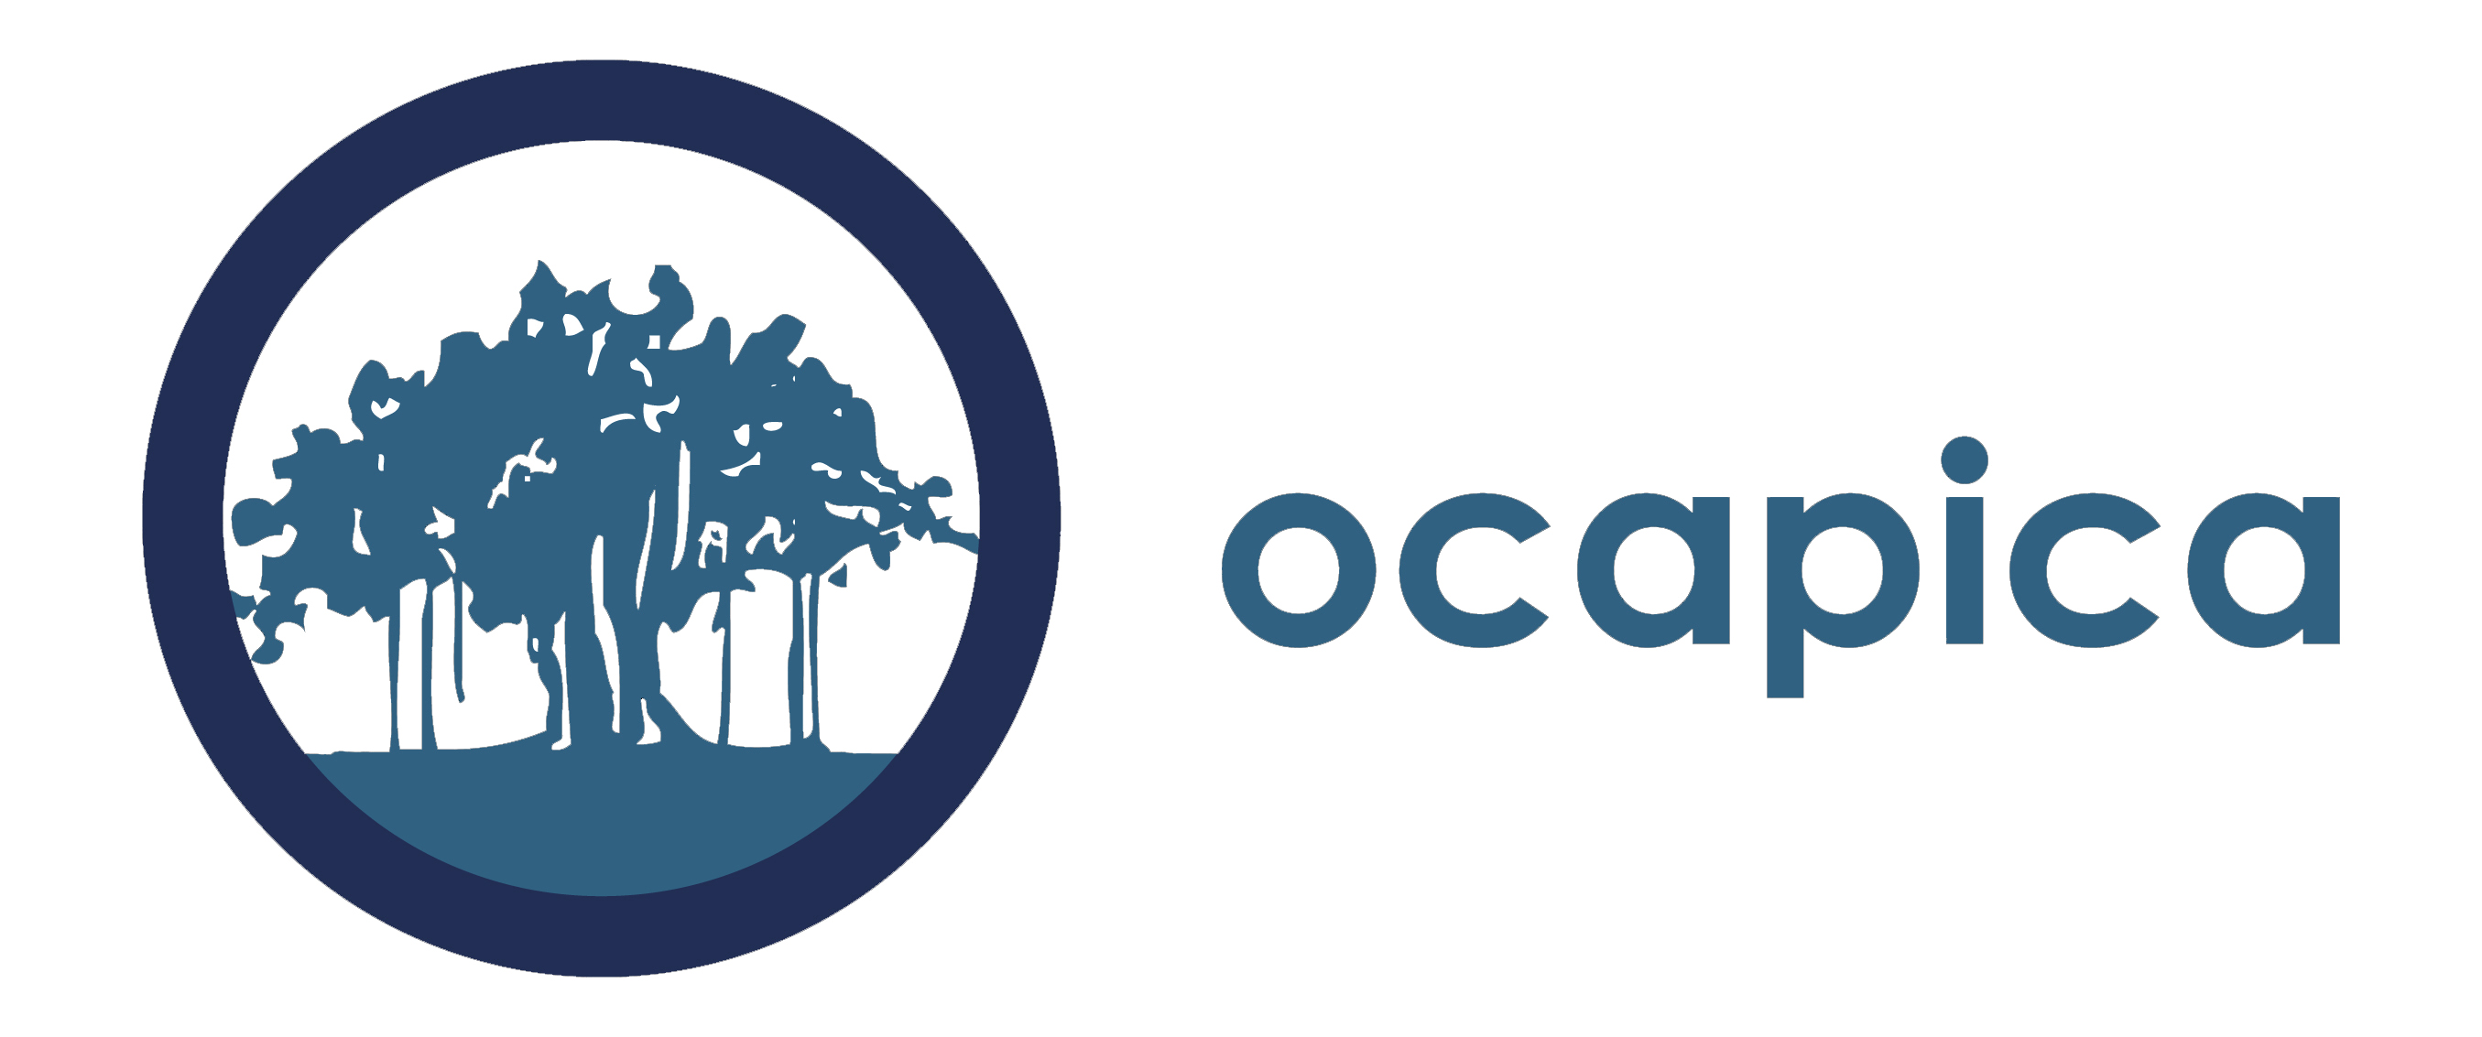 | 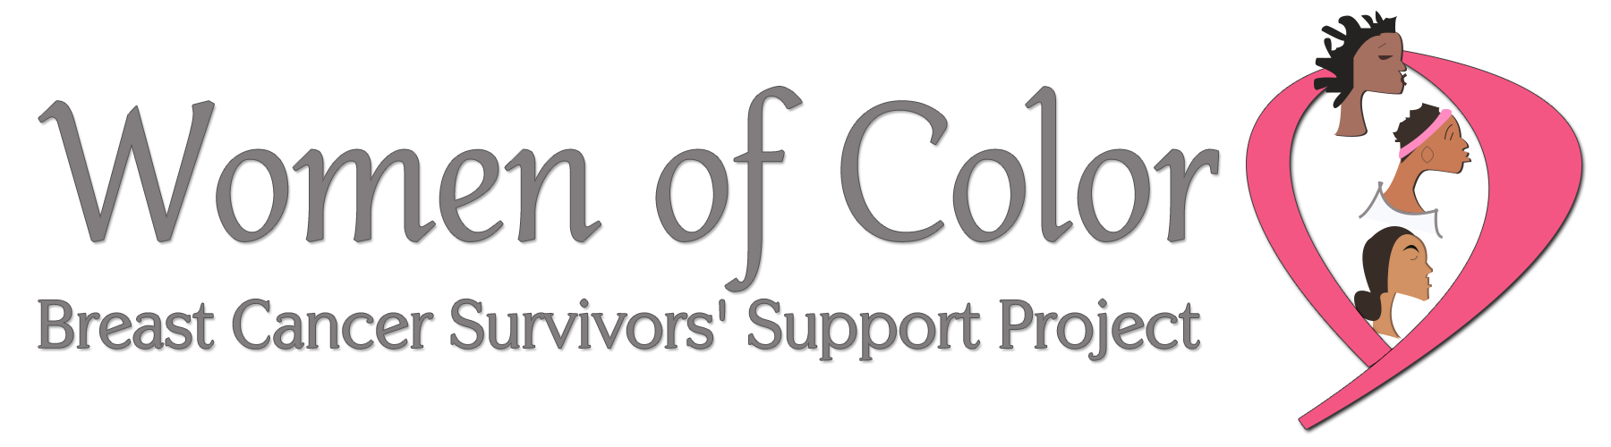

About the QuickStart sponsoring organizations

California Breast Cancer Research Program (CBCRP)
CBCRP is the largest state-funded breast cancer research effort in the nation whose mission is to eliminate breast cancer by leading innovation in research, communication, and collaboration in the California academic and lay communities. One of the primary funding mechanisms is the Community Research Collaboration (CRC) Awards, which provide $150,000 to $600,000 of funding (plus indirect funds) for partnerships of California-based community organizations and research scientists. CBCPR also funds the California Breast Cancer Prevention Initiatives, which focus carefully crafted research initiatives on the effects of the environment on the development of breast cancer, why some groups of women are more likely to get breast cancer or to die from the disease, and breast cancer prevention. Learn more about CBCRP by www.cabreastcancer.org. There you will find additional information about the program, including their focus on community-partnered participatory research.

OCAPICA
The Orange County Asian and Pacific Islander Community Alliance (OCAPICA) is dedicated to enhancing the health, and social and economic well-being of underserved communities in Orange County, California. Established in 1997, OCAPICA serves more than 40,000 community members a year through programs in health, mental health, education, youth development, workforce development, and civic engagement. OCAPICA has more than 100 staff that speak 26 languages including ASL. To learn more about OCAPICA, visit www.ocapica.org.

Women of Color Breast Cancer Survivors’ Support Project (WOC) WOC was created to help survivors navigate the world of recovery and develop self-care plans to aid in their survivorship. WOC supports breast cancer survivors, offer crisis intervention in the healing process, educate women and families on breast health, and actively participate in effective change as it relates to health and racial disparities. Visit www.woc4you.org to learn more about WOC advocacy and programs.
Important Note: Please be sure to fill out the complete application form. This form is included at the end of this PDF. A Word version of the application can be downloaded at http://cbcrp.org/funding-opportunities/crc/quick-start-training.html

For more information contact: QuickStartTP@gmail.com and/or visit: https://www.cabreastcancer.org/funding-opportunities/crc/quick-start-training.html

QuickStart Application Guidelines for
New and Existing Scientist-Community Partnerships

Together the Academic co-PI and Community co-PI should fill out the partnership overview on page 10 and provide complete answers to questions A-C on page 12. Combine all pages of the application into a single word document and email it to QuickStartTP@gmail.com by March 18, 2021, 5pm PST.

Your complete application (excluding letters of reference and resumes/CVs) should not exceed six pages. A downloadable word version of this is also available on the QuickStart webpage: http://cbcrp.org/funding-opportunities/crc/quick-start-training.html

Please submit your application as a word document.

Application Checklist:
Please include the following in your completed application:

- Partnership overview: See form on next page.
- Application questions: See questions on next two pages.
- Letter of Reference. Each of the partners includes a letter of reference from an organization or individual familiar with his/her work. For academic partners, a letter from a previous collaborator is appropriate. For community partners, a letter from your community organization in support of this application is required.
- Resume or Curriculum Vitae (CV) (Not to exceed 4 pages). Each partner must submit either a resume (community partner) or a CV (academic partner) that is not to exceed four pages.

Partnership overview for Academic and Community Partners

Community Co-PI Name
Organization Name
Address
Email
Work Phone
Cell Phone
Fax Number
Executive Director Name
Work Phone
Email
Academic Co-PI Name
Institution
Address
Email
Work Phone
Cell Phone
Fax

How many years has your team worked together? Or, If this is a new partnership, how did you meet?
What previous research studies have you conducted together (if applicable)?
Who is your community of interest?
What disparities issues are of most concern to you?
What environmental issues in breast cancer or tobacco related disease(s) are of most concern to you?
If you are not planning to investigate disparities and/or environmental issues in breast cancer or tobacco related disease, what are your primary issues of concern?
Will the academic Co-PI be submitting a mentorship plan? (See requirements on page 3). If not, please indicate how many post-doctoral years has the research scientist been working in the research field. Please also list the year, funder, and name of study of most recent NIH RO1 funding.

A. Overview of your partnership (2–3 pages).
Together the community co-PI and academic co-PI prepares a two to three page overview in response to the questions below. Please include the questions with the answers filled in underneath when you submit.

  - Who is part of your partnership? What experience, interests, and skills do they bring?

  - Describe your experience and position in your organization/institution.

  - How did your partnership meet and why have you chosen to work together? If you are an existing partnership, how did you begin to work together and what is your history of working together?

  - Describe each partner’s experience working in partnerships and/or collaborations (other than above) and (if applicable) in community-partnered participatory research.

  - Describe your common research interests. For example, describe the types of research questions that are interesting to you.

  - If there are other individuals who are likely to be significantly involved in the research process with your partnership, please describe them and their proposed contribution. Please note: if you would like one of them to be considered for participation in the program, please indicate who they are and why it would be important for them to participate. QuickStart cannot guarantee that more than two partners will be able to participate in the program; however, we will consider a third partner if there is available space.

B. Description of the Organization/Institution Involved (1–2 pages each). Each partner prepares a one to two page overview of their organization/institution they will represent in the QuickStart program, that includes the following details. Please include the questions with the answers filled in underneath when you submit.

- Describe the mission of the organization/institution, the issue the organization/institution focuses on, the geographic reach of the organization/institution, the demographics of the population the organization/institution serves, and the types of services the organization/institution provides.
- Describe your organization/institution’s experience collaborating with others.

- Describe the research interests of the organization/institution (if different than above).

- Given the research needs and interests of the organization/institution, why is the individual applying a good candidate for this program?

- How will the organization/institution select a replacement for the individual if he/she resigns his/her position with the organization/institution?

C. Is there anything else you would like the QuickStart team to know as we consider your application?

